SNOWFLAKE VIEWS
VIEWS:
It is a database object which allows the subset of rows or columns along with dynamic column calculations to be accessed as a table

Let’s see in practical with examples

Checking client table
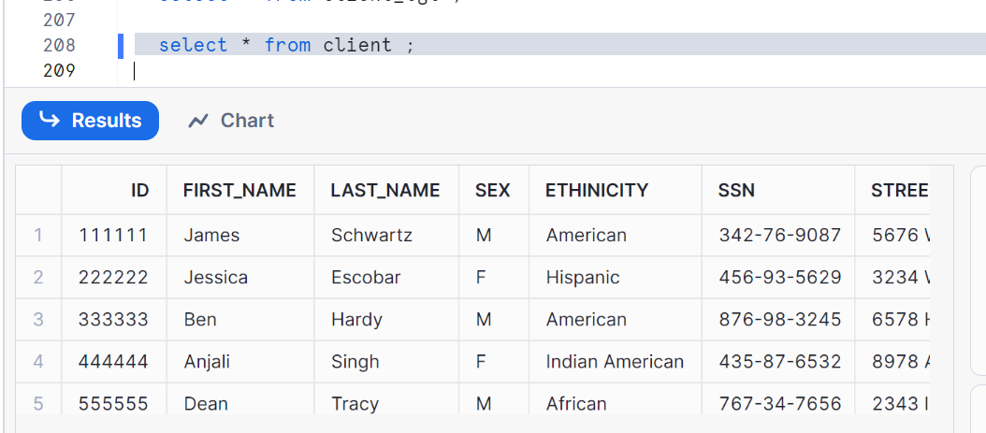
Creating a view to modularize our data
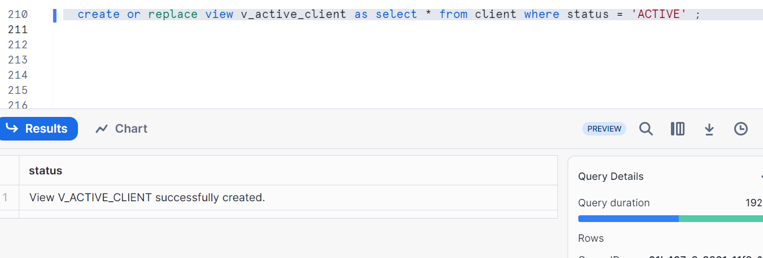

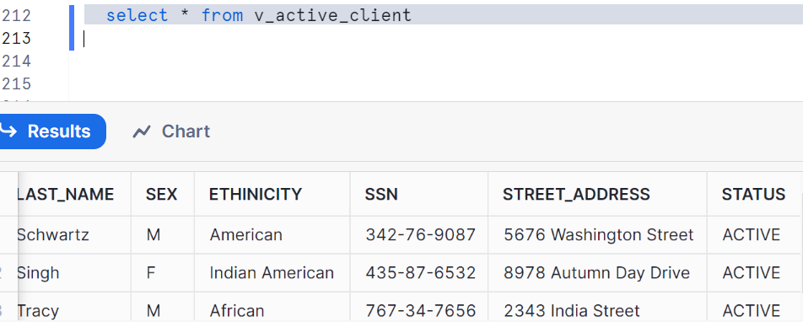
Now creating a view to get few columns out of main table
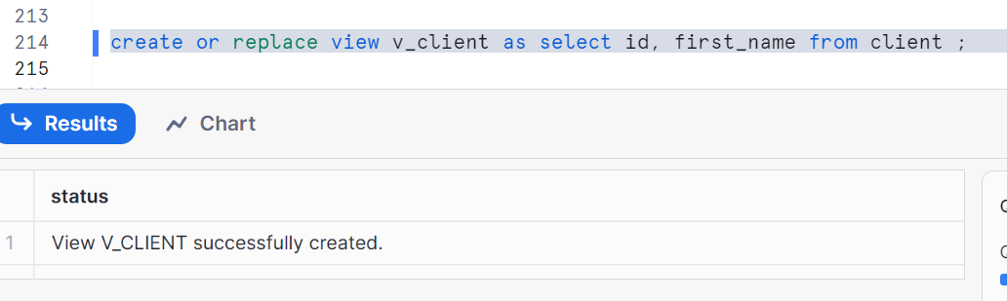
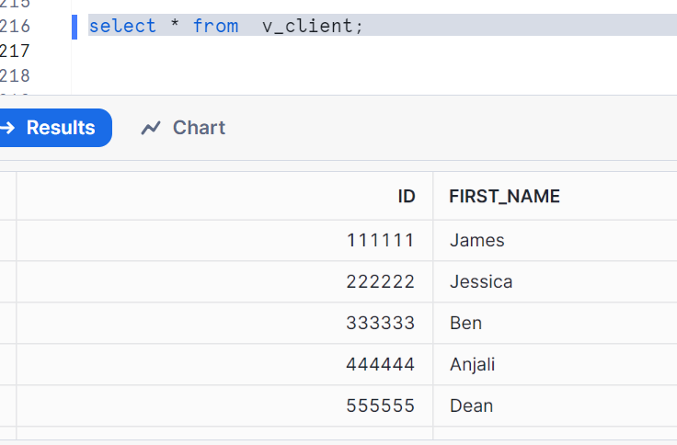
Want to share other example as well where you can perform dynamic operations
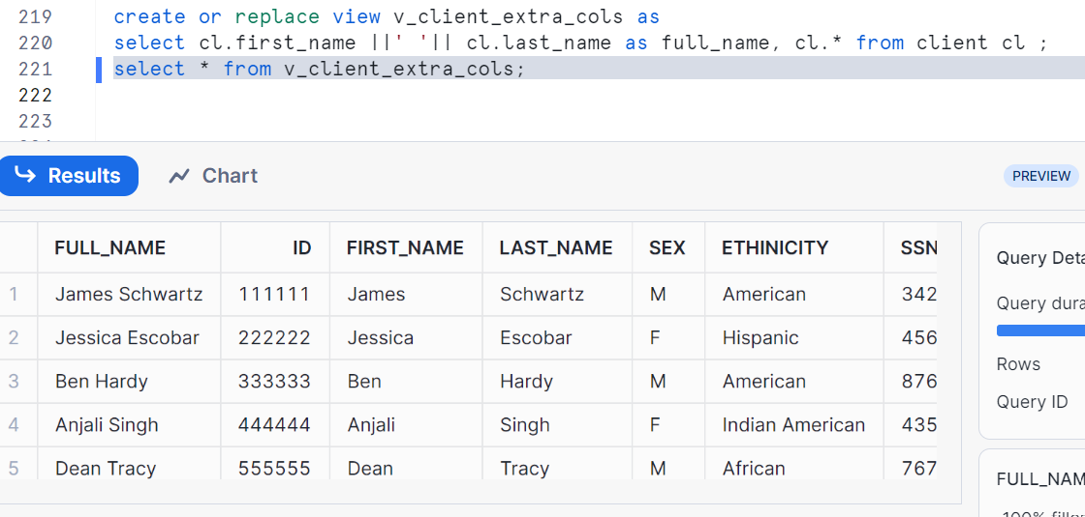
Creating secure view
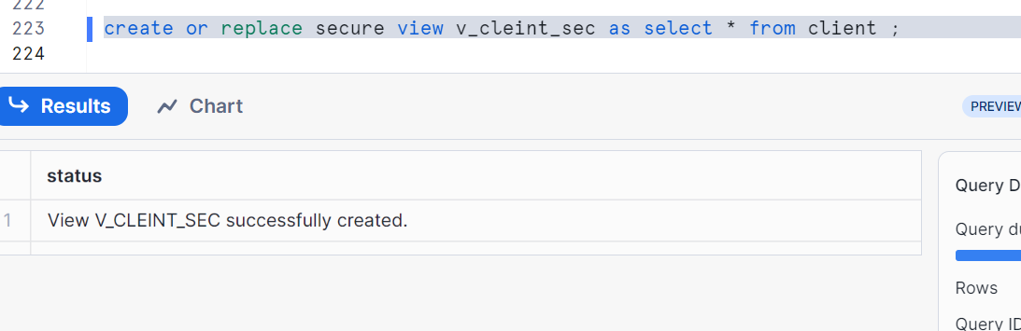
As we have seen in the last post (snowflake_15) that when you create a secure view, the body is not accessible to user if it is shared

Advantages of views:
You can modularize the code and access the subset of the data from the view
Limitations:
Read only views, cannot be altered and main table changes are not propagated to views

Views explained above are non-materialized views, now let’s see what materialized views are!!

Materialized views:
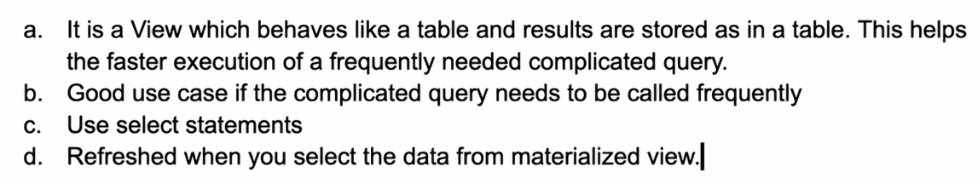
Some note points:
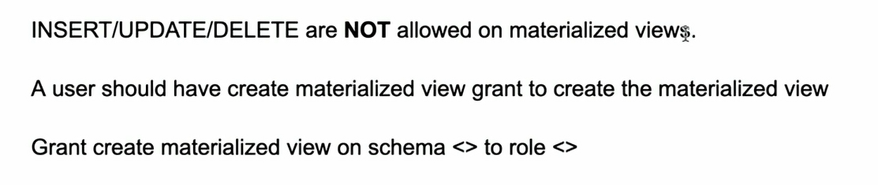
Let’s perform in practical
To check the performance of a materialized view, we will first disable the caching
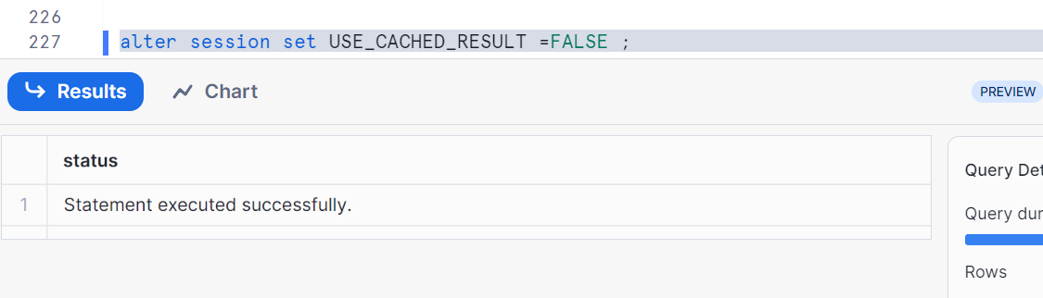
Let’s create a table from other database into present database
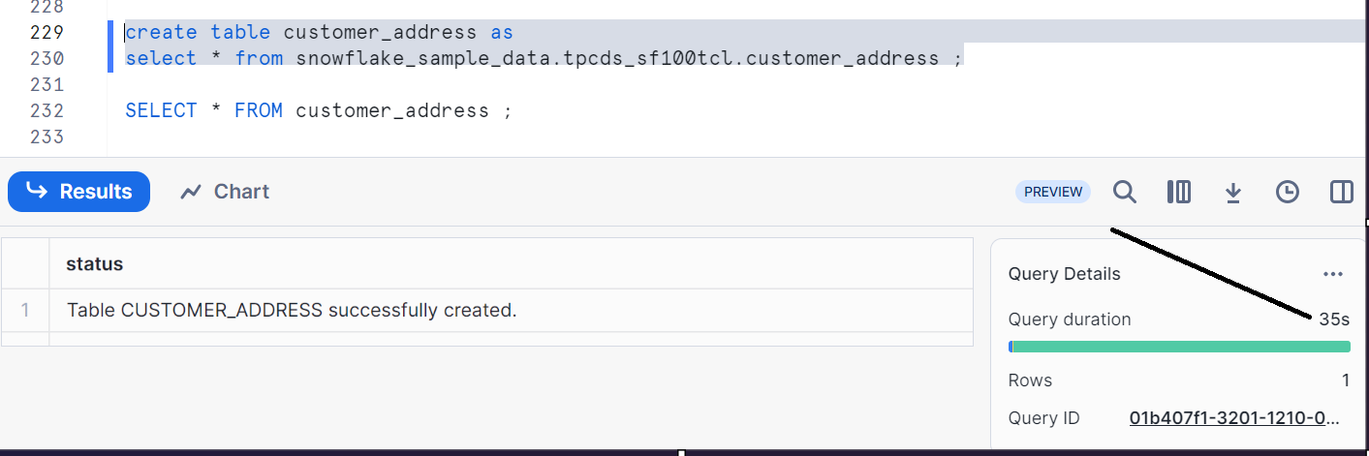
It got executed in 35 sec

Let’s create a little analytical OR complicated columns query which might take some extra time when doing it at run time
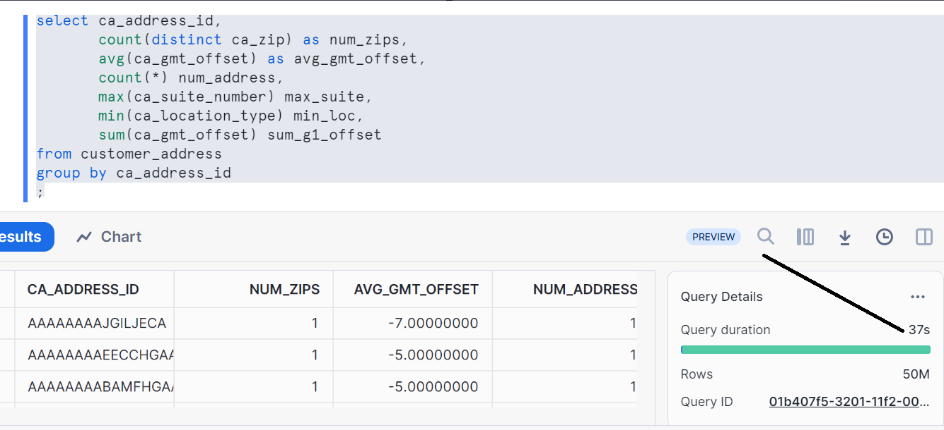
Let’s create a materialized view adding the same query
Understand that all aggregate functions are not allowed in materialized views. Hence I have to commented the count (distinct) in below image
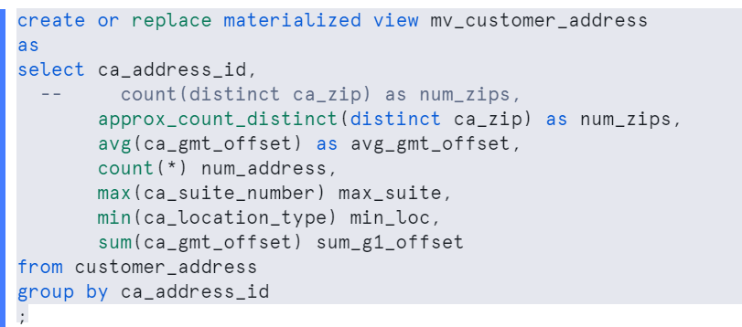
Let’s check Execution time
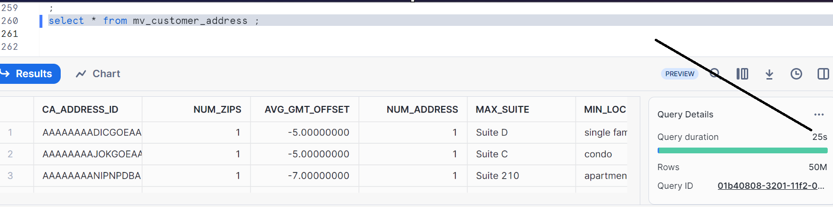
It is 25 sec which is faster than previous
So if you run this frequently this is more efficient.
Checking materialized views
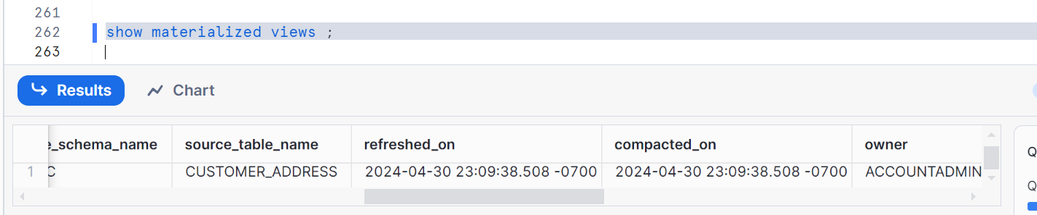

Now let’s do some DML operations – delete and updates and inserts
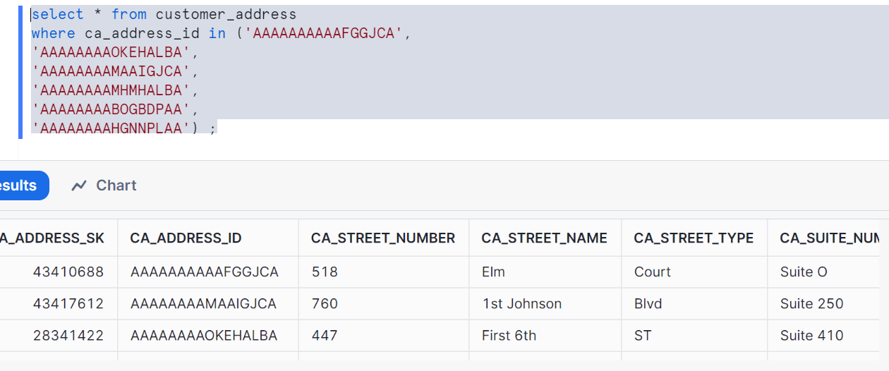

Updating ca_suite_number for specific ca_address_id
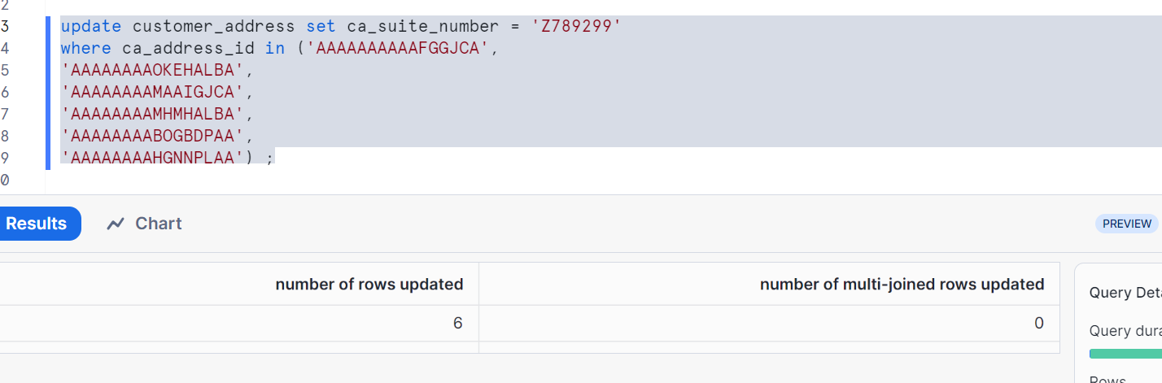
Let's check the query it should show the data
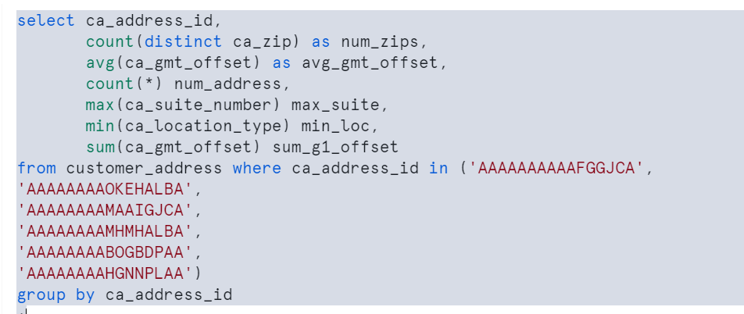
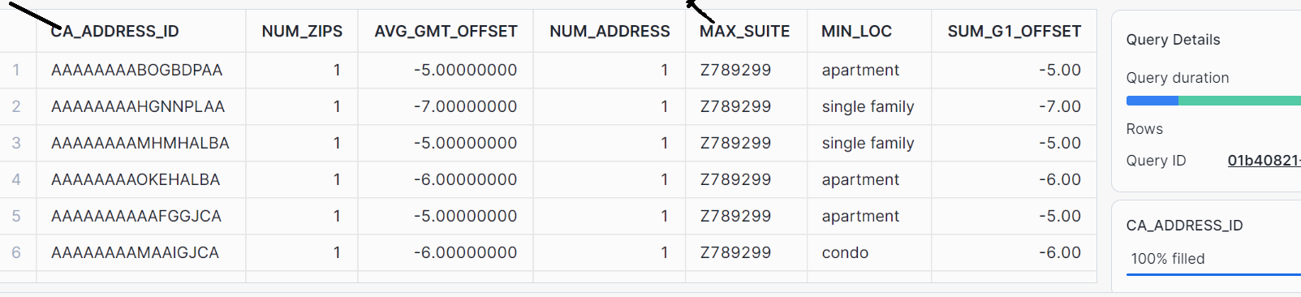
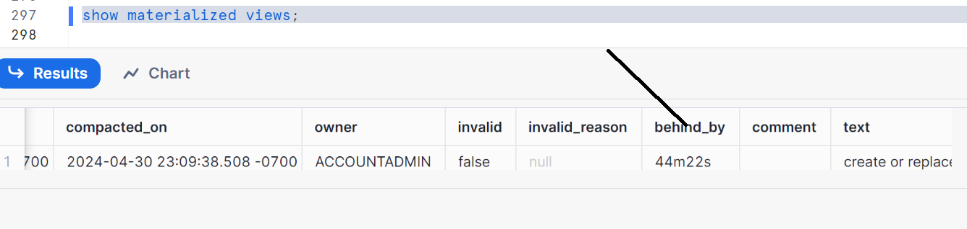
As you have to check behind by implies how far the materialized is behind the updates in the base table
Behind by - 0 means latest
Check compacted on -- what time the materialized view was compacted

Select from materialized view will refresh the view
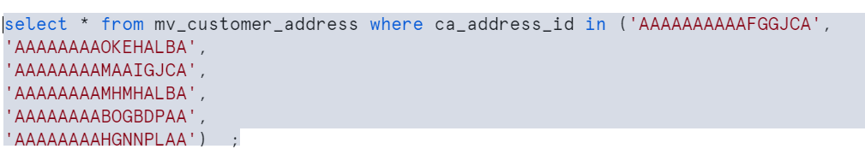
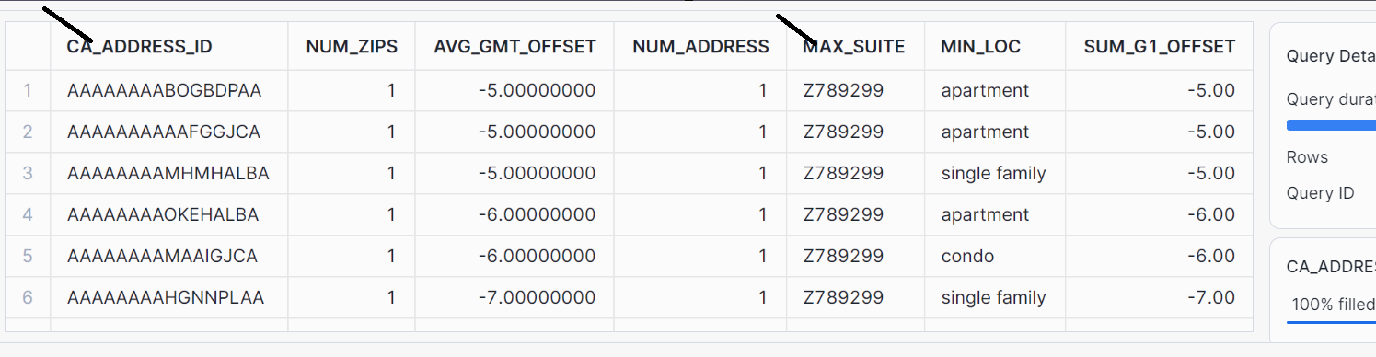
Check the refresh and compacted by again
Show materialized views;
Note: sometimes it doesn’t show you behind by as 0 as snowflake takes time to manage
Key points:
- First select from MV post DML will be a little longer since it refreshes the view. Subsequent runs will be quicker.
- MV is managed by snowflake compute power
- It doesn't use the Warehouse
- You can check the cost of maintenance for materialized view

Materialized view can be suspended, here it is
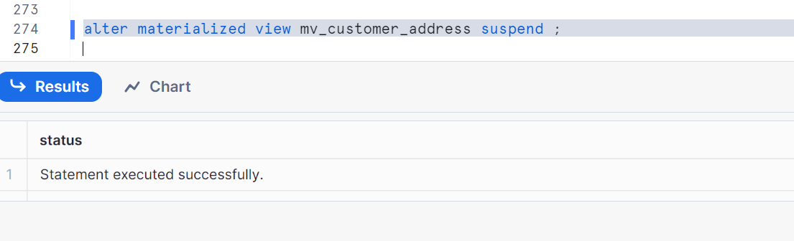
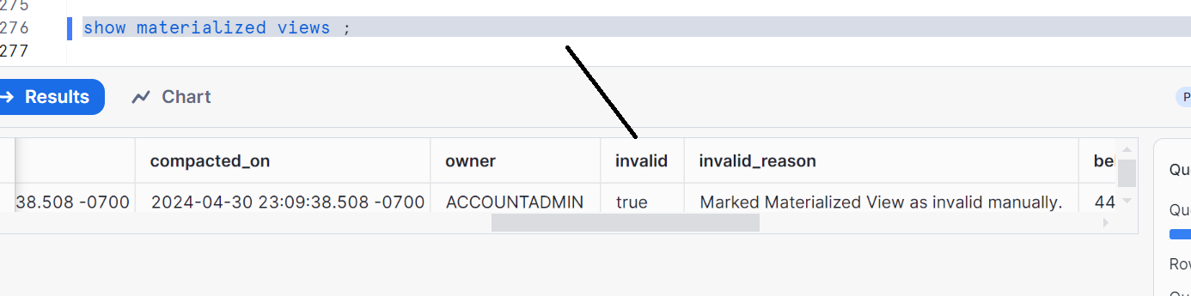
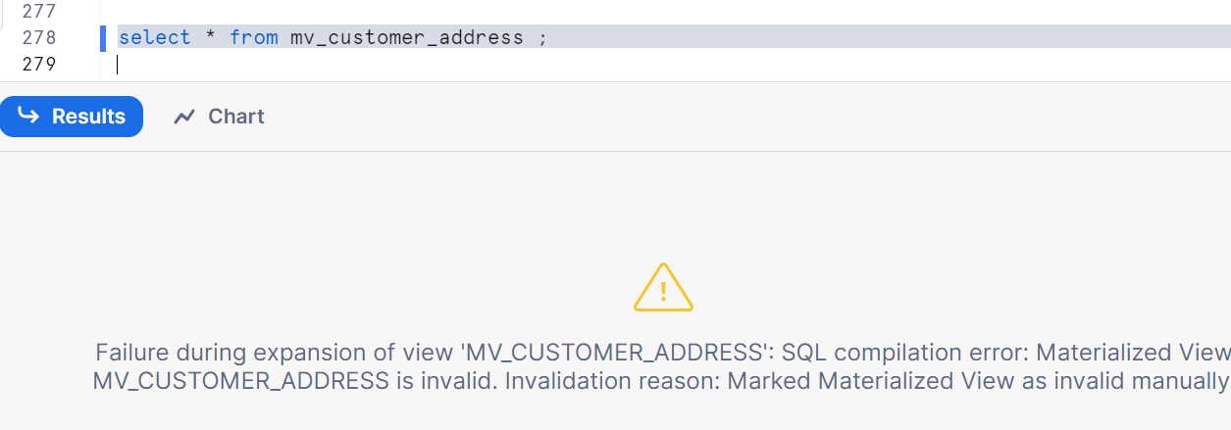

Again to resume after few days, here it is
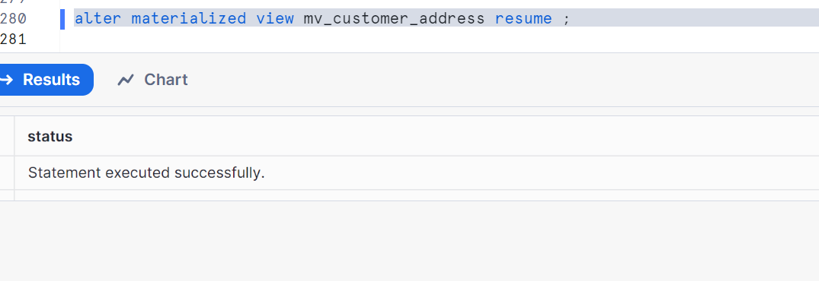
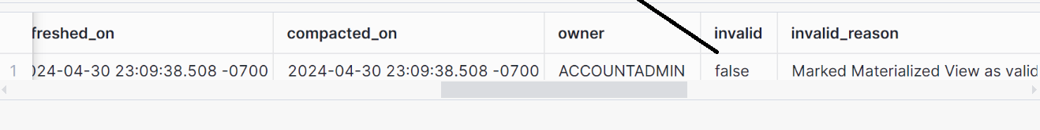check the data now
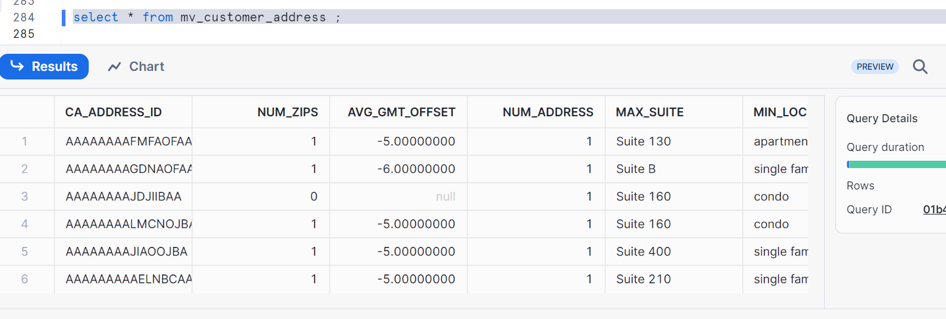

Materialized view can be clustered like a table can be clustered. Here are the steps
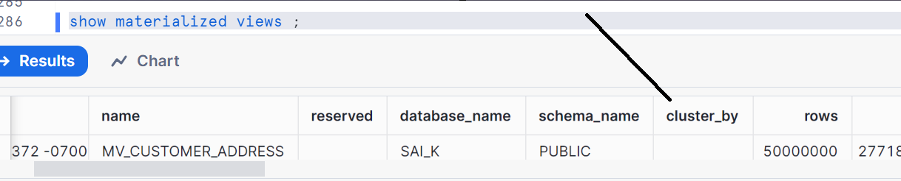
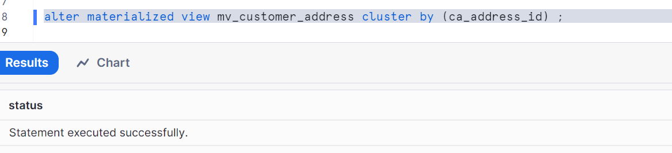
Show materialized views;
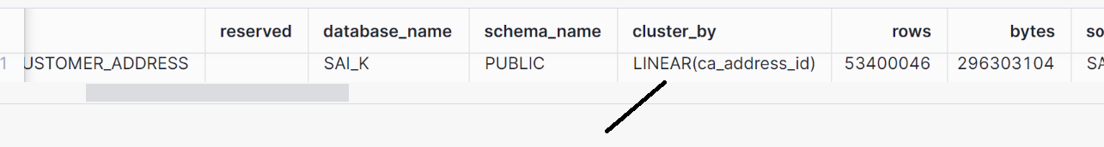
Removing clustering
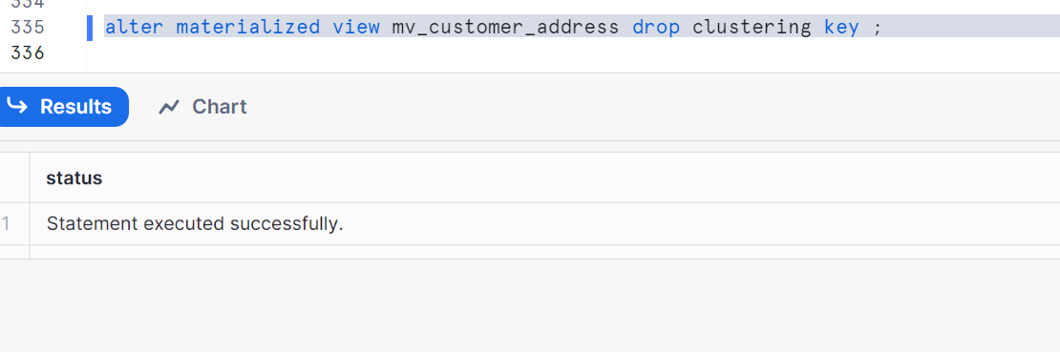

For cleaning up:
Drop table customer_address;
Drop materialized view mv_customer_address;

When to choose MV (materialized view):
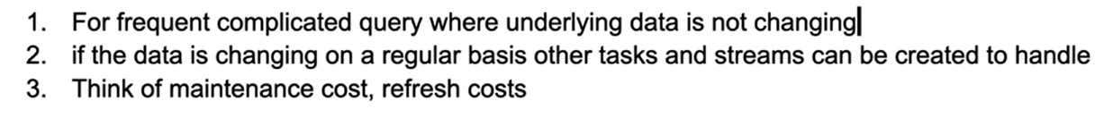
Any terms are not understood, will update you later

Limitations of MV:
